**Option Menu :**Android Options Menu is a primary collection of menu items in an android application and useful for actions over toolbar for few direct features like settings/logout etc. We have various action mode like visible always, visible if room available etc.

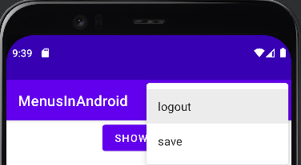

**Context Menu :** Android Context Menu is a floating menu that only appears when the user clicks for a long time on an element and useful for elements that affect the selected content or context frame. For example over any view like a listview of contacts have options over menu to call/sms etc.

I have a real life example that In Whatsapp — Open your WhatsApp Application and long press on any of the chats you have, saw the change? This is a Context Menu in the **action mode**.

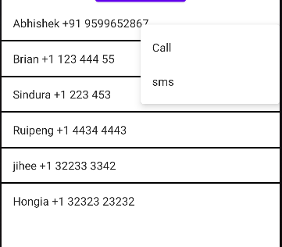

**PopUp Menu :**Android Popup Menu displays a list of items in a vertical list which presents to the view that invoked the menu and useful to provide an overflow of actions that related to specific content. It need an view as **anchor**so below I have a button that acts as anchor to open popUp menu.

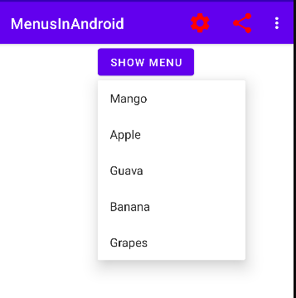

**Few basic attributes of an menu item**

Like any other UI component, even Android menus have also it’s attributes

**android: id**It uniquely identifies the item of the menu.

**android: icon**It sets an icon to represent the item.

**android: title**It sets the title of the item.

**android: showAsAction**It specifies when and how this item should appear as an action item in the app bar.

**Let’s go for implementation of Android Menu**

**Step 1**: create a menu directory inside res directory.

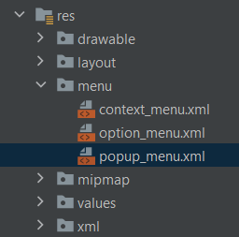

**Step 2**: create menu file by right click on menu dir

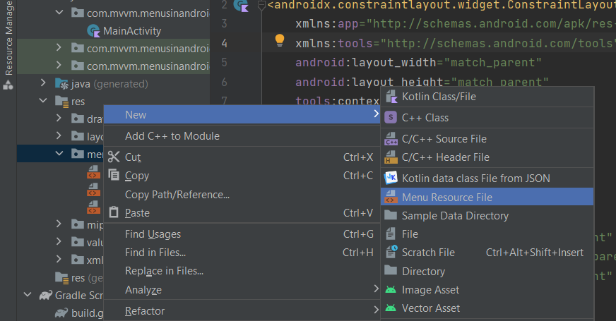

**Step 3**: Implement an menu file by adding items in it.

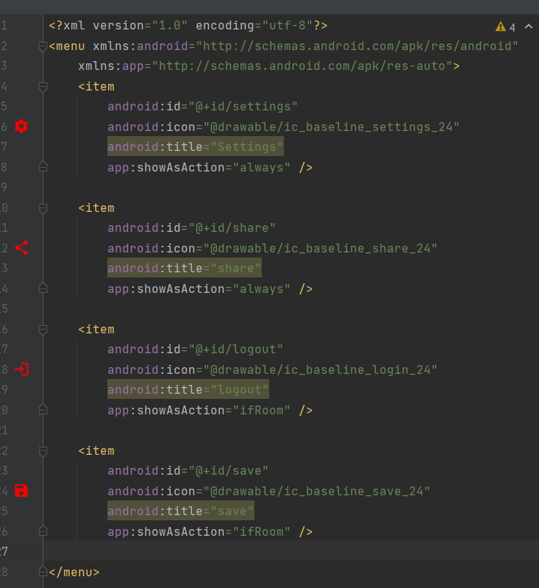

**Step 4:** Implement the menu in the kotlin/Java file

**for option menu —**

override fun onCreateOptionsMenu(menu: Menu?): Boolean {  
 menuInflater.inflate(R.menu.option_menu, menu)  
 return true  
}  
  
override fun onOptionsItemSelected(item: MenuItem): Boolean {  
 return return when (item.itemId) {  
 R.id.share -> {  
 makeToast("share the message")  
 true  
 }  
 R.id.settings -> {  
 makeToast("check the setting")  
 true  
 }  
 else -> super.onOptionsItemSelected(item)  
 }  
}

**For popUp menu -**

private fun popUpMenuWork() {  
 val popupMenu = PopupMenu(  
 this,  
 binding.buttonMenu  
 ) //buttonMenu is an anchor for PopUp menu-> it will create menu  
 popupMenu.menuInflater.inflate(R.menu.popup_menu, popupMenu.menu)  
 popupMenu.setOnMenuItemClickListener {  
 when (it.itemId) {  
 R.id.mango -> makeToast("mango")  
 R.id.apple -> makeToast("apple")  
 R.id.banana -> makeToast("banana")  
 R.id.grapes -> makeToast("grapes")  
 R.id.guava -> makeToast("guava")  
 }  
 true  
 }  
  
binding.buttonMenu.setOnClickListener {  
 popupMenu.show()  
 }  
}  
private fun makeToast(message: String) {  
 Toast.makeText(this, message, Toast.LENGTH_SHORT).show()  
}

**For Context menu —**

private fun contextMenuWork() {  
 val dataContacts = arrayOf(  
 "Abhishek +91 9599652867",  
 "Brian +1 123 444 55",  
 "Sindura +1 223 453",  
 "Ruipeng +1 4434 4443",  
 "jihee +1 32233 3342",  
 "Hongia +1 32323 23232"  
 )  
 val arrayAdapter = ArrayAdapter(this, android.R.layout.simple_list_item_1, dataContacts)  
 binding.listviewContacts.adapter = arrayAdapter  
 registerForContextMenu(binding.listviewContacts)  
}  
  
override fun onCreateContextMenu(  
 menu: ContextMenu?,  
 v: View?,  
 menuInfo: ContextMenu.ContextMenuInfo?  
) {  
 super.onCreateContextMenu(menu, v, menuInfo)  
 menuInflater.inflate(R.menu.context_menu, menu)  
}  
override fun onContextItemSelected(item: MenuItem): Boolean {  
 return when (item.itemId) {  
 R.id.call -> {  
 makeToast("call")  
 true  
 }  
 R.id.sms -> {  
 makeToast("sms")  
 true  
 }  
 else -> super.onContextItemSelected(item)  
 }  
}